Product Search Report
Objective
To retrieve and analyze product information from the E-Commerce database using SQL filtering, sorting, and search operations.
SQL Operations Performed
- Retrieved products within the price range of ₹1,000 to ₹5,000.
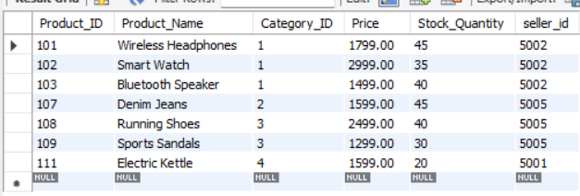
- Searched for products by name using the LIKE operator.
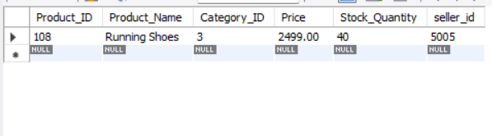
- Displayed products belonging to a selected category.
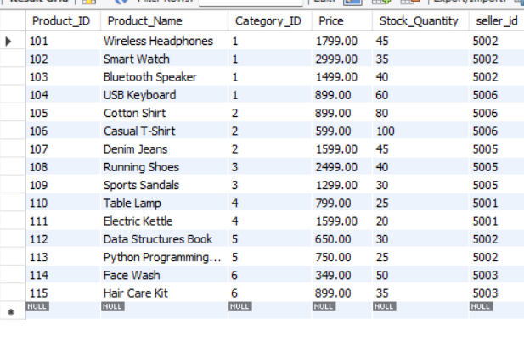
- Identified products currently available in stock.
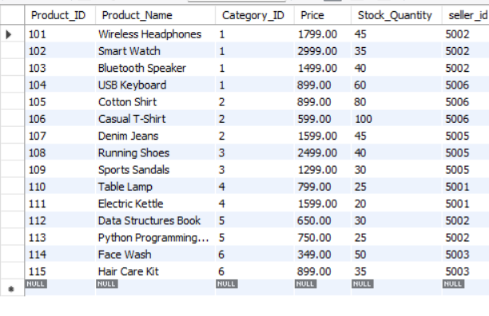
- Identified products with low stock quantities.
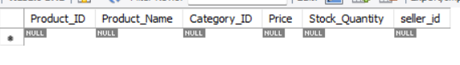
- Displayed products costing more than ₹5,000.
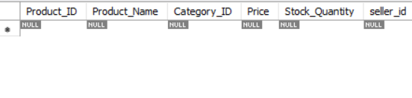
- Sorted products by price in ascending and descending order.
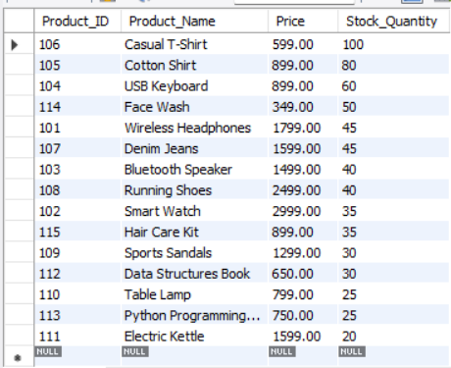
Result
The SQL queries help identify products based on price, category, name, and inventory status. This report supports product discovery, stock monitoring, and basic inventory management.
Conclusion
SQL filtering and sorting operations make it easier to search products efficiently and identify products that require restocking.

